# Experiment 3.2

**Aim:** *Case study of Agriculture 4.0 using IoT and to develop an IoT model for the agriculture sector.*

# Objectives:

1. *Learn about interfacing.*
2. *Learn about IoT programming.*

# Components Used:

* *1 Arduino UNO*
* *Jumper Wires*
* *Soil Moisture Sensor*
* *NPK Sensor*
* *Temperature and Humidity sensor*

# Description:

***Case Study:*** *India is mainly an agricultural country. Agriculture is the most important occupation for the most of the Indian families. It plays vital role in the development of agricultural country. In India, agriculture contributes about16% of total GDP and 10% of total exports. Water is main resource for Agriculture. Irrigation is one method to supply water but in some cases there will be lot of water wastage. So, in this regard to save water and time we have proposed project titled smart irrigation system using IoT. In this proposed system we are using various sensors like temperature, humidity, soil moisture sensors which senses the various parameters of the soil and based on soil moisture value land gets automatically irrigated by ON/OFF of the motor. These sensed parameters and motor status would be displayed on user android application.*

***Introduction:*** *With India's population crossing 1.3 billion in 2016, a balance between the optimum population growth and a healthy of nation is far to be achieved. The rising population, there is a need for increased agricultural production. Irrigated agriculture has been an extremely important source increased agricultural production. Now a days people wants to observe their work from anywhere on their digital devices such as Smartphone and tablet or laptop. Several things were made easy by using Internet of Thing (IoT). This seminar on "IOT base smart irrigation system” is for to create an IOT base automated irrigation mechanism, which turns the pumping motor ON, and OFF on detecting the moisture content and sufficient water level and pass data through IOT platform. It overcome labour intensive work and also controls water management system.*

*the microcontroller 5volts of power is supplied to the micro controller. From that microcontroller a relay gets the information about the percent of the moisture in the soil. If the moisture percent 15 is low then the motor gets automatically ON and the notification is sent to the user device. Block diagram of Arduino based smart irrigation system which consist of three sensors, which are connected to controller and sensed values from these sensors are send to the mobile application.*

**Date of Performance 26/10/2023**

***Test Result:*** *The Smart Irrigation System is integrated into the mobile application system to enable the user to easily monitor and control the irrigation of the farm field. On the mobile application system, there is an interface to view data collected directly from the sensors via the help of the Firebase, which is the cloud that creates a bridge between hardware and the cloud database. The main interface of the mobile application is the main menu that displays the login page of the system. This is to create a secured login for each user and to prevent others from knowing data owned by another client. Once the user successfully login to the app, there is another menu display the options control the irrigation system. The user has to select any of the options to go about the system. The control option leads the user to control the water pump to either force "ON" or "OFF", or just set it to the AUTO mode where it navigates the pump's control based on the sensor's value that set in the system. Then, the control system leads the user to access the BLYNK App. This process is to display percentage of all the sensors, which display the report of the status of the farm field's soil. The flow of the Smart Irrigation System that integrated into the mobile application system.*

***Future Scope:*** *Smart farming based on IoT technologies enables growers and farmers to reduce waste and enhance productivity ranging from the quantity of fertiliser utilised to the number of journeys the farm vehicles have made, and enabling efficient utilisation of resources such as water, electricity, etc. IoT smart farming solutions is a system that is built for monitoring the crop field with the help of sensors (light, humidity, temperature, soil moisture, crop health, etc.) and automating the irrigation system. The farmers can monitor the field conditions from anywhere. They can also select between manual and automated options for taking necessary actions based on this data. For example, if the soil moisture level decreases, the farmer can deploy sensors to start the irrigation. Smart farming is highly efficient when compared with the conventional approach.*

***Conclusion:*** *1) We conclude that this system is easy to implement and time, money and manpower saving solution for irrigating fields.*

*2) A farmer should visualize his agricultural land’s moisture content from time to time and water level of source is sufficient or not. IOT based smart irrigation system displays the values of the sensors continuously in smart phone or on computer’s web page and farmer can operate them anytime from and anywhere.*

## *CODE:*

*const int sensor_pin = A1; /* Soil moisture sensor O/P pin */*

*void setup() {*

*Serial.begin(9600); /* Define baud rate for serial communication */*

*}*

*float moisture_percentage; int sensor_analog;*

*sensor_analog = analogRead(sensor_pin);*

*moisture_percentage = (100 - ((sensor_analog / 1023.00) * 100)); Serial.print("Moisture Percentage = "); Serial.print(moisture_percentage);*

*Serial.print("%\n\n"); delay(5000);*

*}*

## Output and Simulation :

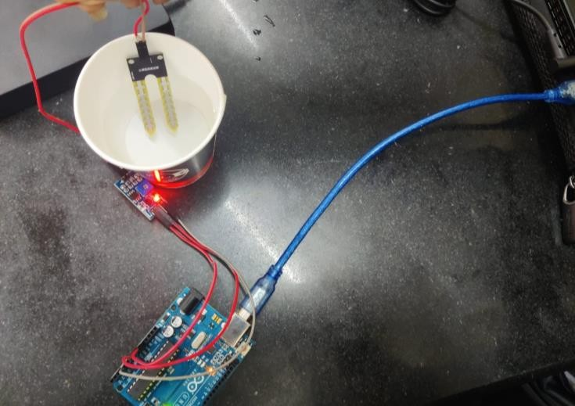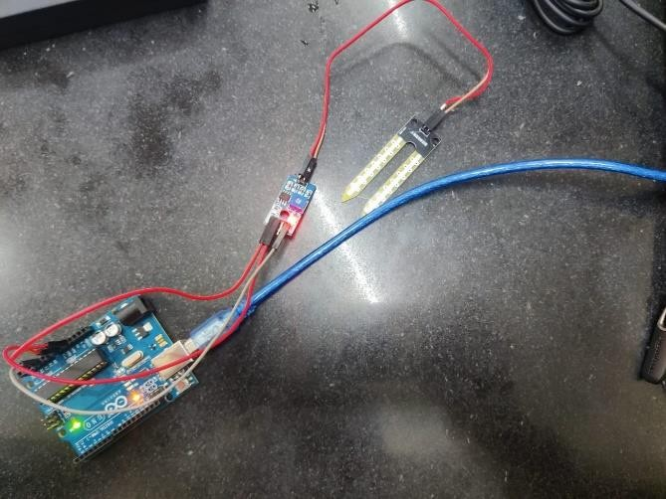

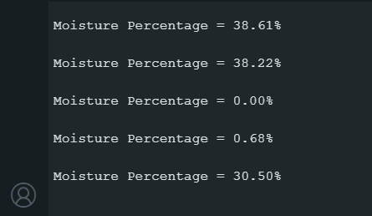

**Learning Outcomes :**

* *Understanding NPK Sensor Technology.*
* *Principles of Moisture.Calculating moisture percentage in a soil.*